**Kathmandu University**

**Department of Computer Science and Engineering**

**Dhulikhel, Kavre**



**A Case Study**

**of**

**“REMOTELY CONTROLLED CAR WITH VR SUPPORT”**

**COMP 306**

**Assignment I**

**Submitted By:**

**Supreeya Karn(17)**

**Kamalesh Kunwar (22)**

**Sunil Prajapati (37)**

**Bibash Shrestha (48)**

**Deepal Singh (55)**

**Submitted To:**

**Mr. Satyendra Nath Lohani**

**Submission Date**

**12/04/2018**

**Introduction**

The specified project is the combination of hardware and software components to build a car which can be remotely controlled through a XBOX controller. It is an example of an innovative embedded systems which can be utilized for certain areas of exploration. It allows humans to control a piece of machine equipment without being physically present at the scene.

**Hardware Components**

1. Google Cardboard

Google Cardboard is installed as a medium for visual feed for the user. It directly feed the live visual feed from stereoscopic camera to the smartphone mounted on it. The accelerometer of the smart phone is used to control the movement of the camera mounted on the car. It utilizes cardboard and a pair of 40mm focal distance lenses to turn the smartphone into a virtual reality headset. It uses magnet, Velcro, and a rubber to keep the content intact.

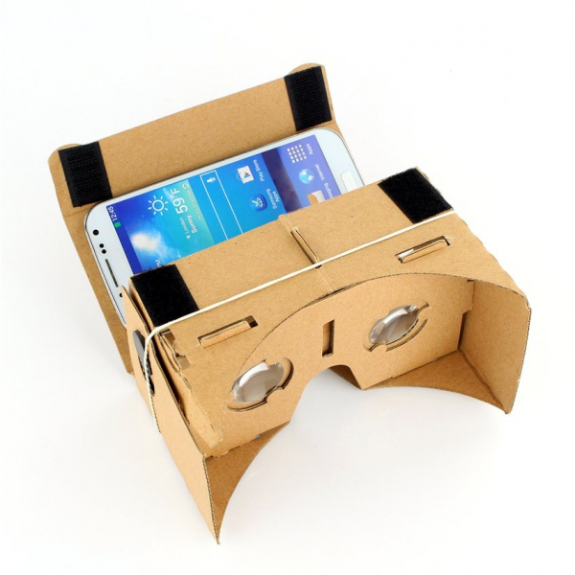

Fig. Google Cardboard

2.  Raspberry Pi

Raspberry Pi is used as the brain of the project, processing the video from the stereoscopic camera and live streaming to the smart phone intact in Google Cardboard. It also the controls the wheels of the car by processing the input from the Xbox controller. In addition, the pi is also responsible for processing the movements of the VR set to correspond the movement of the camera mounted in front of the car. The car is provided with two Raspberry Pis for faster processing. Two Pis have divided tasks, such that all the components work smoothly in simultaneously manner. Both Raspberry Pi are powered by 5V battery.

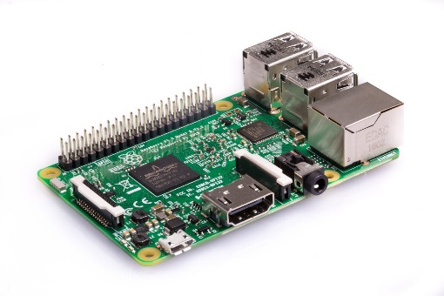

Fig. Raspberry Pi 3

3.  XBOX Controller

A wireless XBOX controller is used to control the directions and movements of the car. A chip XBOX receiver is connected to the Raspberry Pi, to connect the controller to the system. When the buttons and joystick are used, controller sends signals to the receiver, which in its part sends received signal to Pi for processing.

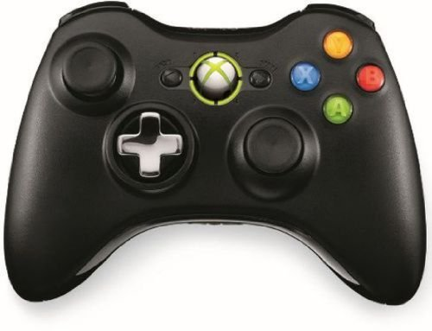

Fig. XBOX 360 Controller

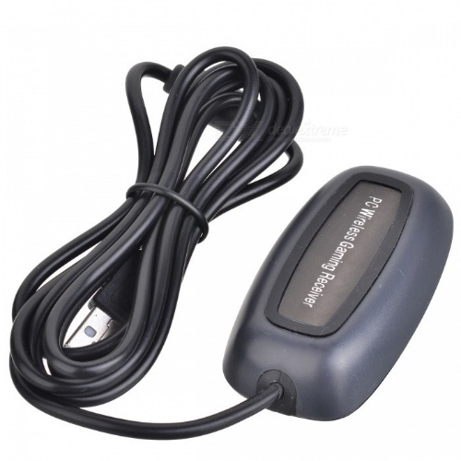

Fig. XBOX Wireless Reciever

4.  Camera Setup with Polulu Micro Maestro 6 board

A stereoscopic camera is used to record the live video of the environment in front of the car, which can be fed to the smartphone in the VR set. The camera is mounted on the duo servo motors which are controlled by Polulu Micro Maestro 6 board. The servo motors can move the camera in precise Up/Down and Left/Right direction corresponding to the information received from the accelerometer from the smartphone. The motors are powered by 9.6V battery pack.

The camera is connected to the Raspberry Pi, which allows to stream the video over the network.

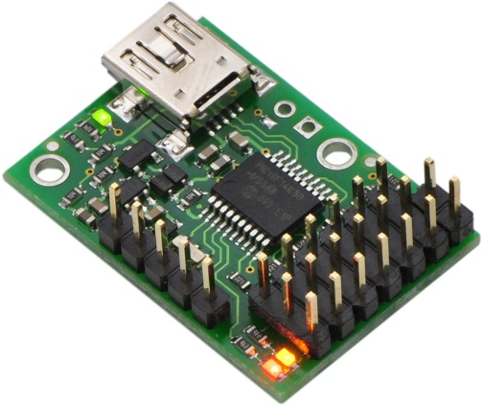

Fig. Polulu Micro Maestro 6 Board

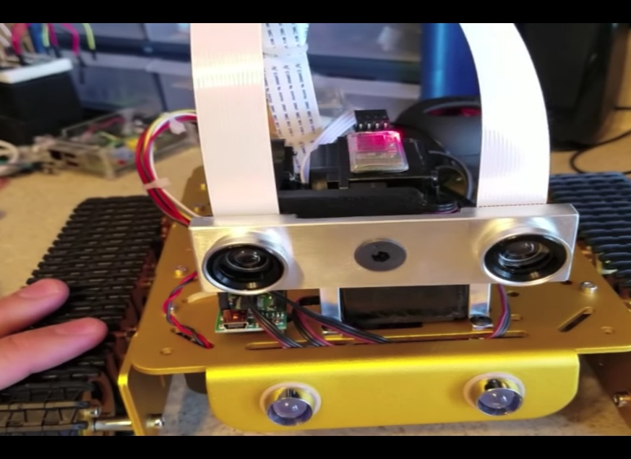

Fig. Front View of the Car

**Software Components**

1. Android App

An android app tracks the data from the accelerometer and magnetometer to calculate the orientation of the smartphone. The data is sent over Bluetooth to the Polulu Micro Maestro 6 board which drives the servo motors. The android app is built on Java. The video is made VR accessible by streaming the video on two browsers placed on the smartphone’s screen adjacently.

2. UV4L(User space Video4Linux)

The video is streamed to the smartphone using UV4L streaming service which has a webtrc plugin that serves the video to any local client with a fairly low amount of latency. The smartphone and the Pi has to be connected to the same network.

3. Xbox Gamepad User space Driver for Linux

The XBOX controller driver is called xboxdrv. A module written in python interprets pygame events to be utilized as programmer’s wish. Polulu Motor controller grabs the values from the analog sticks that are converted to PWN which in turn drives the motors.

**Conclusion**

It is a prototype for the vehicles which could be used in less human-friendly environment such as space exploration, mining, ocean exploration, radioactive zones, warzones and much more. The immersive experience and easy to learn controls makes it more accessible to larger demographic. The concept of VR for immersive experience can also be implemented for gaming industry to make new games better than before.

**References**

Freddy, K. ( 2016, May 6) Google Cardboard Xbox 360 controlled Raspberry Pi VR Robot Tank. Retrieved from<https://www.youtube.com/watch?v=z9gSZwVMybc>

Freddy, K. ( 2017, September 17) Google Cardboard Xbox 360 controlled Raspberry Pi VR Robot Tank. Retrieved from https://www.eeweb.com/featured-projects/google-cardboard-xbox-360-controlled-raspberry-pi-vr-robot-tank

O’Hanlon, Martin (2014, October 17) Raspberry Pi, Xbox 360 controller, Python. Retrieved from<http://www.stuffaboutcode.com/2014/10/raspberry-pi-xbox-360-controller-python.html>

(2017, April 29) UV4L WebRTC has now landed on the Raspberry Pi Zero and Zero W models!. Retrieved from<http://www.linux-projects.org/2017/04/29/uv4l-webrtc-for-pizero/>

Wikipedia (2018, April 11) Google Cardboard. Retrieved from<https://en.wikipedia.org/wiki/Google_Cardboard>